**IBM Project**

**Report**

**On**

Ambulance Tracker

### Developed By: -

Anuj Jani (21162102003)

Rahul Makwana (20162171011)

Vedant Patel (20162171020)

### Guided By:-

Prof. Umang Thakkar(Internal)

Mr. Nirav Rajgor (External)

**Submitted to**

**Department of Computer Science & Engineering Institute of Computer Technology**



**Year: 2024**

# CERTIFICATE

This is to certify that the **IBM** Project work entitled **“**Ambulance Trackerby Anuj Jani (21162102003) Rahul Makwana (20162171011) Vedant Patel (20162171020) of Ganpat University, towards the partial fulfillment of requirements of the degree of Bachelor of Technology Computer Science and Engineering, carried out by them in the CSE(CBA/BDA/CS) Department at ICT GANPAT UNIVERSITY. The results/findings contained in this Project have not been submitted in part or full to any other University for award of any other Degree.

Name & Signature of Internal Guide

Name & Signature of Head

**Place: ICT - GUNI**

### Date: 8/2/2023

**ACKNOWLEDGEMENT**

IBM project is a golden opportunity for learning and self-development. I consider myself very lucky and honored to have so many wonderful people lead me through in completion of this project. First and foremost, I would like to thank Rohit Patel, Principal, ICT, and Prof. Dharmesh Darji , Head, ICT who gave us an opportunity to undertake this project. My grateful thanks to Prof. Umang Thakkar & Mr.Nirav Rajgor (Internal & External Guides) for their guidance in project work Ambulance Tracker, who despite being extraordinarily busy with academics, took time out to hear, guide and keep us on the correct path. We do not know where would have been without his help. CSE department monitored our progress and arranged all facilities to make life easier. We choose this moment to acknowledge their contribution gratefully.

**Anuj Jani (21162102003)**

**Rahul Makwana (20162171011)**

**Vedant Patel (20162171020)**

**ABSTRACT**

This abstract introduces an ambulance tracker mobile application designed to improve emergency response systems. The application utilizes GPS technology to provide real-time tracking of ambulance locations, enabling users to request assistance and monitor ambulance arrival times. Key features include a user-friendly interface, automated location updates, and integration with emergency services dispatch systems. The application aims to enhance the efficiency of ambulance dispatch, reduce response times, and ultimately improve outcomes for individuals in need of urgent medical attention.

**INDEX**

|  |  |
| --- | --- |
| **SR NO** | **TITLE** |
| **1** | **Introduction** |
| **2** | Project Scope |
| **3** | PROCESS MODEL |
| **4** | Objectives |
| **5** | **Contextual Overview** |
| **6** | **Feasibility Study** |
| **7** | **Recommended Approach** |
| **8** | **Tools And Technology** |
| **9** | UI,UX |
| **10** | **Key Features for an Ambulance Tracker Application** |
| **11** | **Modules** |
| **12** | **Database** |
| **13** | **Hardware-Integration** |
| **14** | **Conclusion** |

**CHAPTER: 1 INTRODUCTION**

In emergency situations, timely access to medical assistance can be a matter of life and death. However, the process of locating and dispatching ambulances faces numerous challenges, leading to delays that can significantly impact patient outcomes. Existing ambulance tracking systems often suffer from inefficiencies, hindering the overall emergency response process.

**Challenges:**

1. Timely Dispatch: Delays in dispatching ambulances can result in critical consequences for patients, especially those in life-threatening situations.

2. Inefficiencies: Current ambulance tracking systems may lack real-time updates, leading to inaccuracies in ambulance location and delayed response times.

3. Coordination: Limited integration with emergency services dispatch systems can hamper effective communication and coordination between dispatchers and emergency responders.

**Solution:**

Our solution is a comprehensive ambulance tracker mobile application designed to address the challenges faced by current systems. Leveraging cutting-edge GPS technology and user-friendly interface design, our application aims to streamline the ambulance dispatch process and optimize response times.

**Key Features:**

1. Real-time GPS Tracking: Our application provides real-time updates on ambulance locations, ensuring accurate and timely dispatch.

2. Automated Alerts: Users can request assistance with a simple tap and receive automated alerts on the status of their request and the estimated arrival time of the ambulance.

3. Integration with Dispatch Systems: Seamless integration with emergency services dispatch systems facilitates efficient communication and coordination between dispatchers and emergency responders.

4. User-Friendly Interface: The application features an intuitive and easy-to-use interface, allowing users to quickly access emergency services with minimal effort.

**Benefits:**

1. Improved Response Times: By providing real-time updates and streamlining the dispatch process, our application significantly reduces response times, potentially saving lives in critical situations.

2. Enhanced Coordination: Integration with dispatch systems ensures effective communication and coordination between all parties involved in the emergency response process.

3. User Satisfaction: The user-friendly interface enhances user experience, making it easier for individuals to access emergency services when needed.

### CHAPTER: 2 PROJECT SCOPE

The Ambulance Tracker system is designed to revolutionize emergency medical services by providing real-time tracking and monitoring of ambulance locations, aiming to enhance dispatching efficiency, reduce response times, and ultimately improve patient outcomes. Its architecture encompasses ambulance units equipped with GPS devices for location tracking, a central server for receiving and processing location data, a dispatching interface for managing assignments, and integration interfaces to seamlessly connect with existing emergency services and hospital systems. Through robust GPS integration, data encryption, and redundancy measures, the system ensures secure and reliable transmission of ambulance location data. Dispatchers can access a user-friendly dashboard to assign the nearest ambulance to emergency calls, while integration with emergency call centers and hospital systems facilitates coordinated responses and patient care. Scalability, performance, reliability, and compliance considerations are paramount in the system's implementation, with thorough testing and phased deployment strategies ensuring smooth operation. Maintenance and support services guarantee ongoing system optimization and user satisfaction. In summary, the Ambulance Tracker system represents a comprehensive solution poised to transform emergency medical services through efficient dispatching, real-time monitoring, and seamless integration with existing systems.

### CHAPTER: 3 PROCESS MODEL

### CHAPTER: 4 Objectives

The objective of this project is to enhance emergency medical services through a comprehensive system designed to achieve multiple goals. Firstly, the system aims to enable real-time tracking of ambulance locations, ensuring swift and efficient deployment during emergencies. It also seeks to integrate seamlessly with emergency call centers, facilitating quick dispatch of ambulances upon receiving distress calls. Additionally, the system intends to improve communication between ambulances and hospitals by sending alerts to healthcare facilities when ambulances are an route with patients, thereby enabling timely preparation for patient intake. Finally, the project aims to provide accurate estimated time of arrivals (ETAs) to hospitals and patients awaiting ambulance services, leveraging real-time data to optimize resource allocation and minimize response times in critical situations. The primary goal is to significantly enhance emergency response times through the implementation of a robust ambulance tracking system. This system will leverage advanced technologies to provide real-time tracking of ambulance locations, enabling emergency services to precisely monitor and coordinate the movement of vehicles in response to incidents or distress calls. By seamlessly integrating with emergency call centers, the system ensures rapid dispatch of ambulances to the scene of emergencies, effectively reducing the time between receiving a distress call and the arrival of medical assistance. Moreover, the system's capability to send alerts to hospitals when ambulances are en route with patients facilitates proactive preparation for patient intake, streamlining the admission process and enabling timely provision of medical care. Through the provision of accurate estimated time of arrivals (ETAs) to hospitals and patients awaiting ambulance services, the system optimizes resource allocation and minimizes uncertainty, ultimately leading to a significant improvement in overall emergency response efficiency and, most importantly, saving lives.

**CHAPTER: 5 Contextual Overview**

In emergency medical situations, the timely arrival of ambulances is paramount, directly impacting patient outcomes and survival rates. However, existing systems often encounter challenges in accurately tracking and managing ambulance fleets, leading to delays in response times and inefficient resource allocation. These challenges may stem from outdated technologies, limited communication channels between emergency call centers and ambulance services, or inadequate data integration capabilities. Nonetheless, technological advancements offer a promising opportunity to address these shortcomings and streamline emergency response systems. With the advent of real-time tracking technologies, such as GPS and IoT sensors, coupled with robust data analytics and communication protocols, it becomes feasible to develop a comprehensive ambulance tracking system that enables precise monitoring of vehicle locations, facilitates seamless integration with emergency call centers for rapid dispatch, and provides accurate ETAs to hospitals and patients. By harnessing these advancements, emergency response systems can be significantly improved, ensuring swifter and more effective medical assistance during critical situations.

**CHAPTER: 6** **Feasibility Study**

The market analysis indicates a notable demand from ambulance providers for tracking applications, reflecting a growing recognition of the pivotal role that real-time tracking plays in optimizing emergency response services. With GPS technology readily available, tracking vehicle locations has become increasingly accessible, aligning with the willingness of ambulance providers to invest in installing trackers within their fleets. Simultaneously, hospitals express a strong desire for real-time estimated time of arrivals (ETAs) from ambulances, highlighting the urgent need for enhanced communication and coordination between emergency services and healthcare facilities. Moreover, the widespread coverage provided by modern mobile networks ensures reliable connectivity across most regions, laying a solid foundation for implementing advanced tracking and communication systems. This convergence of factors presents a significant opportunity to revolutionize ambulance response metrics, offering the potential to drastically improve response times, patient outcomes, and overall efficiency in emergency medical services.

**CHAPTER: 7 Recommended Approach**

To develop a native mobile app using Kotlin for real-time ambulance tracking, begin by installing GPS trackers in all ambulances to collect location data. Integrate GPS modules into the app for real-time tracking, ensuring seamless communication between the app and the GPS trackers. Implement a secure API for communication with emergency call centers, enabling efficient transmission of critical information such as ambulance location, status, and destination. This API should employ encryption protocols and authentication mechanisms to safeguard sensitive data. Additionally, design the app with user-friendly interfaces for both emergency responders and call center operators, providing them with intuitive tools to coordinate and manage emergency situations effectively. Regular testing and updates should be conducted to ensure optimal performance and reliability of the app and its integrated features, ensuring swift response times and potentially saving lives.

**CHAPTER: 8 TOOLS AND TECHNOLOGY**

In this scenario, we're building a mobile application utilizing Kotlin as the programming language, integrating GPS capabilities of the device to track ambulance locations in real-time.

Leveraging Firebase as the backend database, we ensure seamless data management, storage, and retrieval. The mapping software, such as Google Maps API, is utilized to display ambulance locations dynamically on the map interface within the application. Through Kotlin's robust features, we establish efficient communication between the application frontend and Firebase backend, enabling real-time updates of ambulance positions. Users can conveniently track nearby ambulances, their routes, and estimated arrival times, facilitating prompt emergency response.

The integration of GPS, Firebase, and mapping software in Kotlin streamlines the development process while ensuring a reliable and responsive ambulance tracking system for improved emergency services.

## 

## 

## CHAPTER: 9 UI,UX

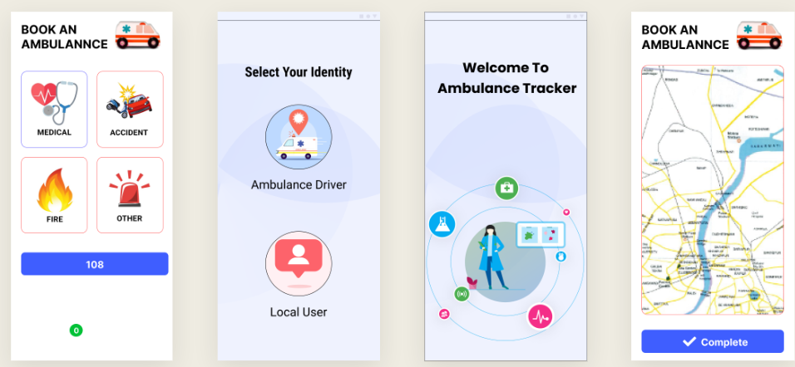

**CHAPTER: 10 Key Features for an Ambulance Tracker Application**

**CHAPTER: 11 Modules**

**Splash Screen**

The application features a visually appealing splash screen that serves as the initial entry point for users, providing a captivating and branded experience upon launching the application. It sets the tone for the overall user interface and enhances the application's perceived professionalism.

**Login Module**

The login module allows existing users to securely access the application by entering their credentials, typically an email address and password combination. This module employs industry-standard security practices, such as password hashing and salting, to protect user data and maintain confidentiality.

**Signup Module**

The signup module caters to new users who wish to create an account within the application. During the signup process, users are prompted to provide essential information, including a valid email address and a strong password.

**Email Verification**

To ensure the integrity of user accounts and prevent potential abuse, the application implements an email verification process. Upon successful registration, the application sends a unique verification link to the user's provided email address. Users must access their email accounts and follow the verification instructions to activate their newly created accounts.

Overall, the combination of the login and signup modules, integrated with the splash screen and email verification, provides a comprehensive and secure authentication system, ensuring a seamless and trustworthy user experience within the application.

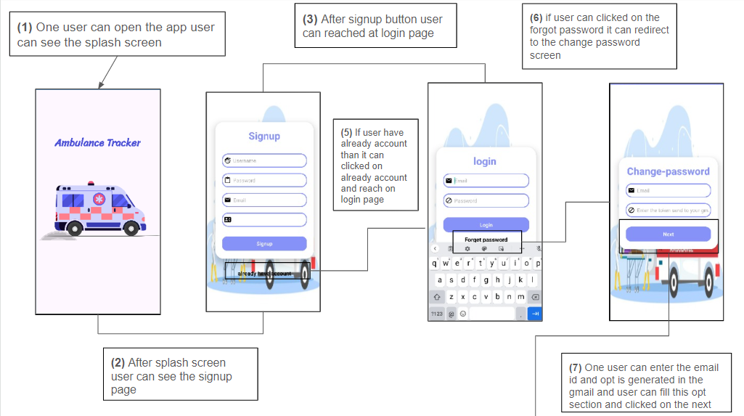

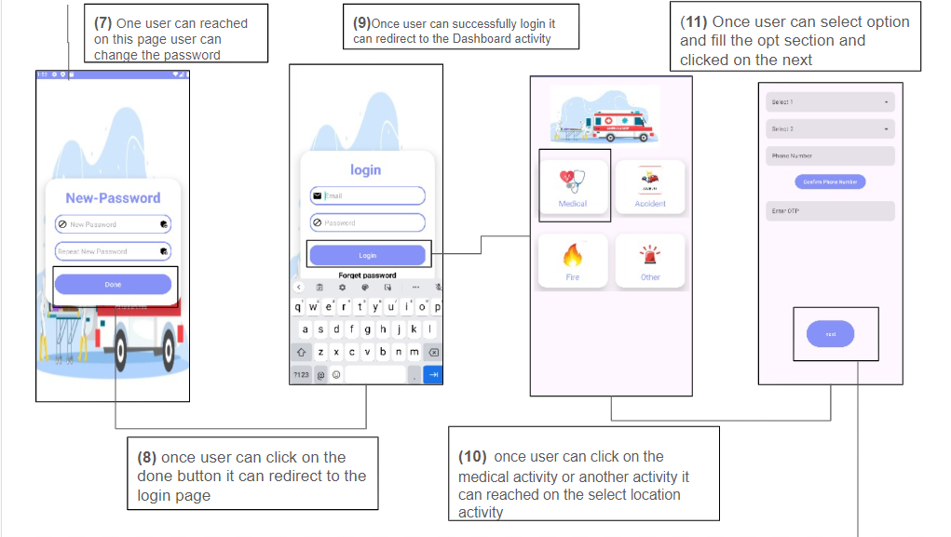

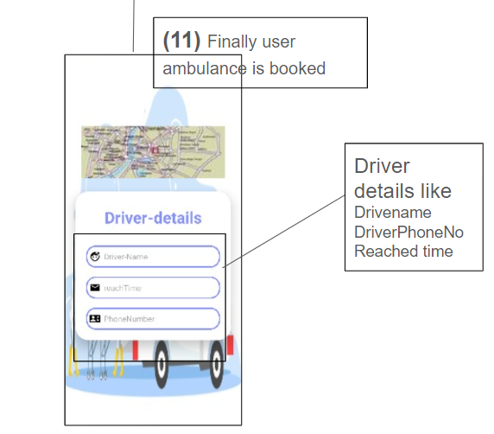

**CHAPTER: 12 Firebase**

**Firebase Integration**

**Authentication with Firebase Authentication**

The application leverages the power of Google Firebase Authentication for managing user authentication and authorization. Firebase Authentication provides a comprehensive and secure solution for handling user sign-up, sign-in, and account management operations.

During the signup process, Firebase Authentication handles the creation of new user accounts, including email and password verification. The email verification functionality is seamlessly integrated with Firebase Authentication, ensuring the validity of user email addresses and preventing the creation of fraudulent accounts.

For the login process, Firebase Authentication securely authenticates users by verifying their provided credentials against the stored information in the Firebase database. This robust authentication mechanism safeguards user data and prevents unauthorized access to the application.

**User Data Storage with Cloud Firestore**

In addition to authentication, the application utilizes Cloud Firestore, a flexible and scalable NoSQL cloud database provided by Firebase, for storing and managing user data. Cloud Firestore offers real-time data synchronization, ensuring that user information is consistently up-to-date across all connected devices and clients.

Upon successful user registration and authentication, relevant user data, such as profile information, preferences, and application-specific data, are securely stored in Cloud Firestore. This approach allows for efficient data retrieval, modification, and synchronization, enabling a seamless user experience across multiple devices or platforms.

Firebase Integration Benefits

By leveraging the powerful features of Firebase Authentication and Cloud Firestore, the application benefits from a robust and scalable backend infrastructure. Firebase Authentication provides a secure and reliable authentication mechanism, while Cloud Firestore offers a flexible and efficient data storage solution.

**CHAPTER: 13 Hardware-Integration**

**13.1 Introduction**

Imagine being able to track the location of your car, bike, or even a loved one in real-time, using a simple and affordable device. This is now possible with the IoT-based GPS location tracker, which uses a NodeMCU board and a GPS module to track and save location coordinates on Google Maps.

**13.2 Components Required for GPS Location Tracker**

* NodeMCU ESP8266
* NEO-6M GPS Module
* OLED Display Module
* FP6291 Boost Converter IC
* 3× Resistor (10k, 100k, 48k)
* 6× Capacitor (2×0.1µf, 1×10µf, 2×20µf)
* 1× Inductor (4.7µH)
* 1× Diode (1N5388B RLG)
* 18650 Lithium Cell
* 18650 Cell Holder
* 6-Pin Push Button Switch

**13.2 Components Introduction**

**NodeMCU ESP8266**  = it is the Wi-Fi module that can be used to add Wi-Fi connectivity to your projects. It has a built-in microcontroller that can be programmed to perform various tasks, such as sending and receiving data over Wi-Fi.

**NEO-6M GPS Module** =The NEO-6M GPS module is a device that receives signals from GPS satellites and uses them to determine its own location and altitude. It communicates this information through a serial connection, using the NMEA protocol.

**OLED Display Module** = The OLED Display Module is a type of display that can be connected to a NodeMCU ESP8266 to show information. It has a small size and low power consumption, The module can display text, numbers, images, and graphics.

**FP6291 Boost Converter IC** =The FP6291 Boost Converter IC is a power management device that can be used to increase the voltage of a power supply. It is commonly used in electronic circuits to power sensors, microcontrollers, and other components that require a higher voltage than the available power supply.

**18650 Lithium Cell =** The 18650 Lithium Cell is a type of rechargeable battery used in the GPS location tracker device. It is a cylindrical battery, commonly used in portable electronics, and is known for its high energy density and long life.

**18650 Cell Holder =** The 18650 Cell Holder is a component in the GPS location tracker device that holds the 18650 Lithium Cell in place. It is a mechanical structure that keeps the battery securely fastened, ensuring proper electrical contact and preventing damage to the battery. By holding the battery in the correct position, the cell holder helps to ensure the proper operation of the GPS tracker.

**6-Pin Push Button Switch =**  A 6-pin push button switch is a type of switch that is used to manually control the flow of electricity in a circuit. It has six pins, two of which are connected to the power source, two to the load, and the remaining two are used for switching the circuit on and off

**13.3 IoT Based Location Tracker Circuit Diagram**

This HAT includes a NodeMCU, NEO-6M GPS Module, OLED Display Module, and a booster circuit based on the FP6291 Boost Converter IC. The booster circuit raises the battery voltage from 3.7V to 6V. This location tracking board is suitable for tracking cars, bikes, and other objects.

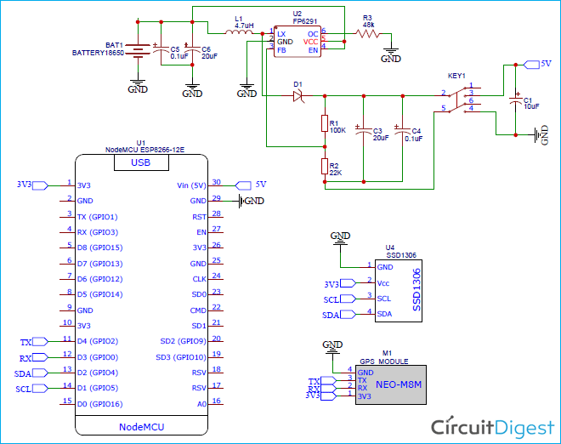

**13.4 IoT Final Working model**

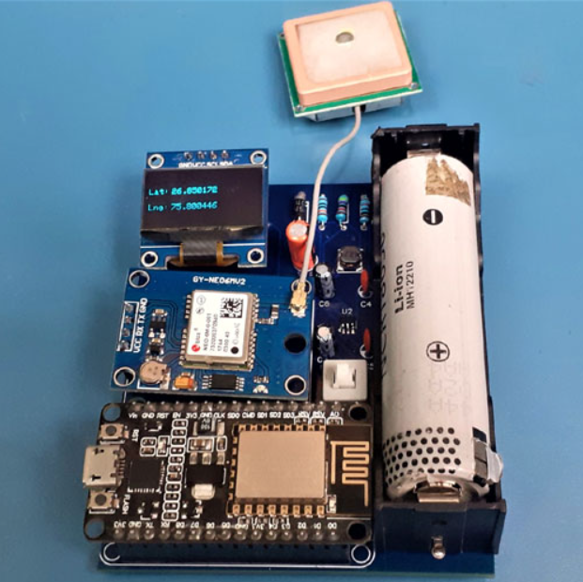

Prepare the hardware and upload the code to the NodeMCU board. Power the setup. Look at the GPS module's LED. If it's blinking, the module is trying to connect to a satellite to get coordinates. If not, move the GPS module to an open area. In the serial monitor, find the NodeMCU's IP address. In a web browser, type in the NodeMCU IP address and press ENTER. You’ll see the location, date, and time displayed on the web page.

**13.5 final-working-Devices**

When you run the code it can displayed the location Details like Latitude, Longitude and Date

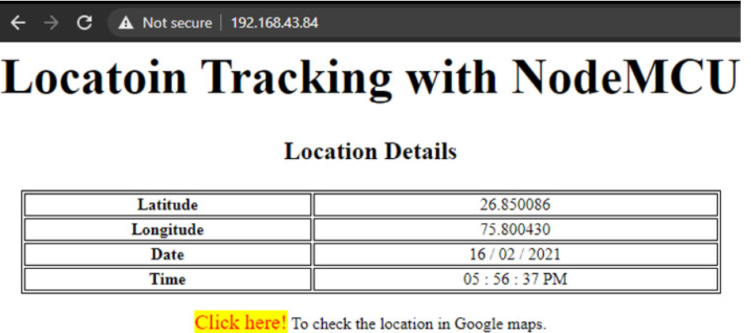

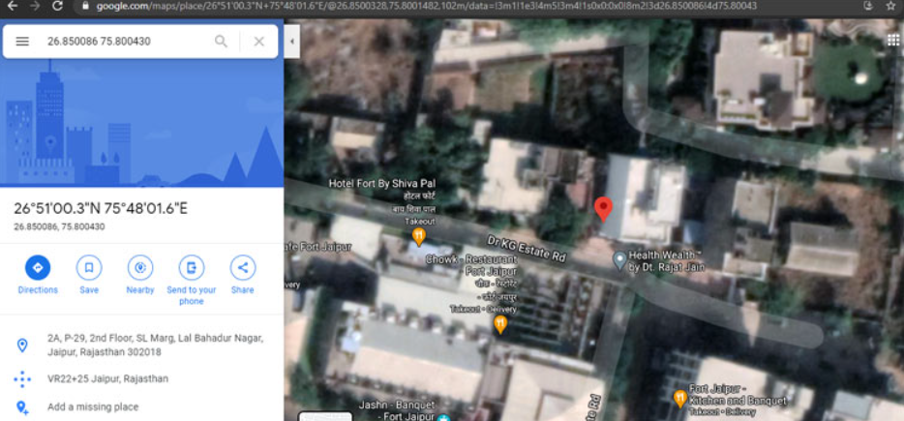

**CHAPTER: 14 Final-Application - flow**

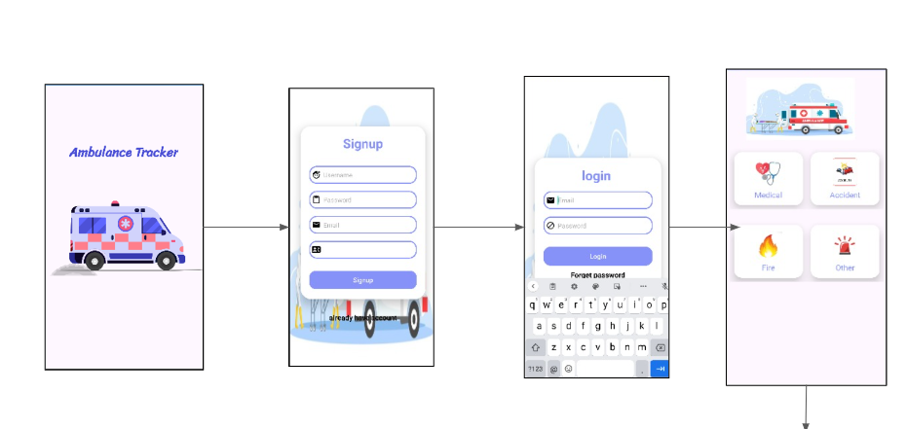

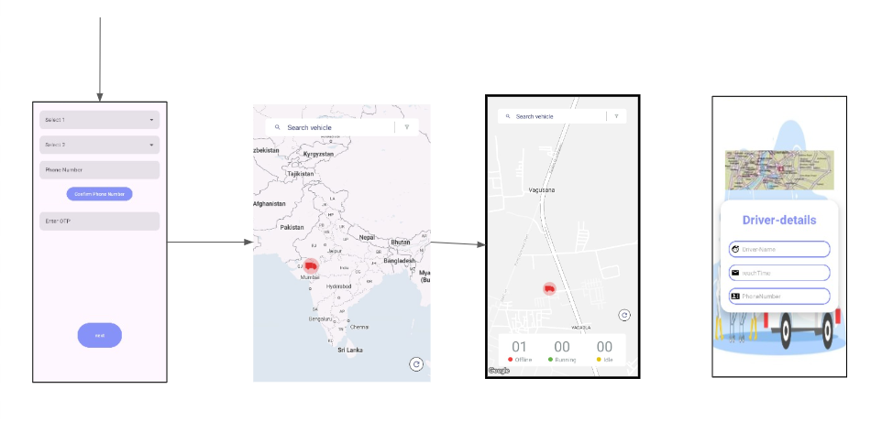

The project flow begins with the user opening the application, where they are greeted by a splash screen. After a brief display, the splash screen transitions to the signup screen, where users can create a new account or log in if they already have one. Once logged in, users are directed to the dashboard, which offers various options for them to choose from. Upon selecting any option, the user is redirected to the ambulance booking system.

Within the ambulance booking system, users can seamlessly book an ambulance for their needs. After successfully booking, users are then presented with a map interface where they can track the live location of the ambulance they've booked. This real-time tracking feature enhances user experience by providing them with the convenience and assurance of knowing the ambulance's whereabouts as it approaches their location. Overall, the project ensures a smooth user journey from signup to ambulance booking and live tracking, prioritizing ease of use and efficiency.

**Conclusion**

In conclusion, our application offers a seamless and user-friendly experience from the moment users open it to when they successfully book an ambulance. Beginning with a welcoming splash screen, users are guided through the signup process or prompted to log in if they already have an account. Once logged in, they are greeted with a comprehensive dashboard offering various functionalities. However, the core feature lies in our ambulance booking system, where users can effortlessly secure medical transport tailored to their needs.

The integration of real-time tracking elevates the user experience by providing a sense of security and control. With just a glance at the map interface, users can monitor the exact location of their booked ambulance, ensuring timely assistance during critical moments. This emphasis on efficiency and convenience underscores our commitment to prioritizing user satisfaction and enhancing accessibility to essential medical services.

In essence, our project encapsulates the fusion of technology and compassion, seamlessly connecting users with vital healthcare resources when they need it most. By streamlining the process from signup to ambulance booking and live tracking, we aim to empower individuals with the confidence and assurance that help is always within reach."